Counting and measuring the size of seeds in one operation with Scion software

Open the file “seeds for scion.bmp”. This a picture of Brassica rapa seeds in silhouette. Using the density slice tool from the “Options” pull-down menu, adjust the LUT selection until the seeds are entirely red, which means you’ve selected the entire cross-sectional area of each seed.

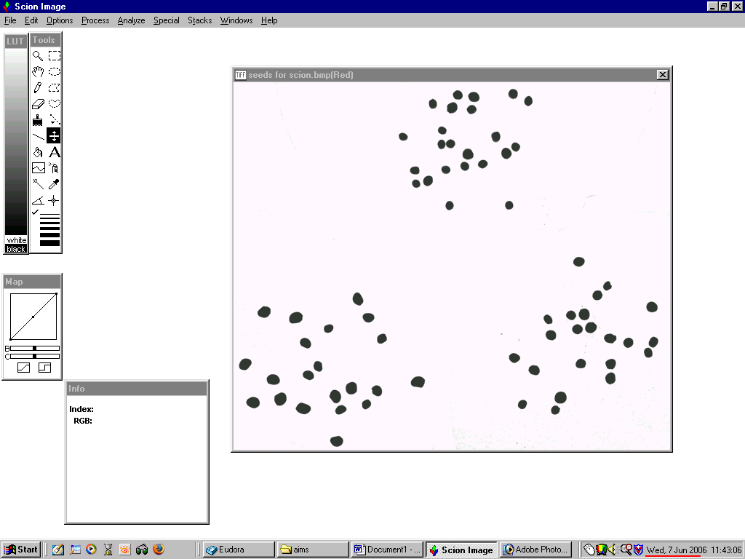

Your screen should look like this:
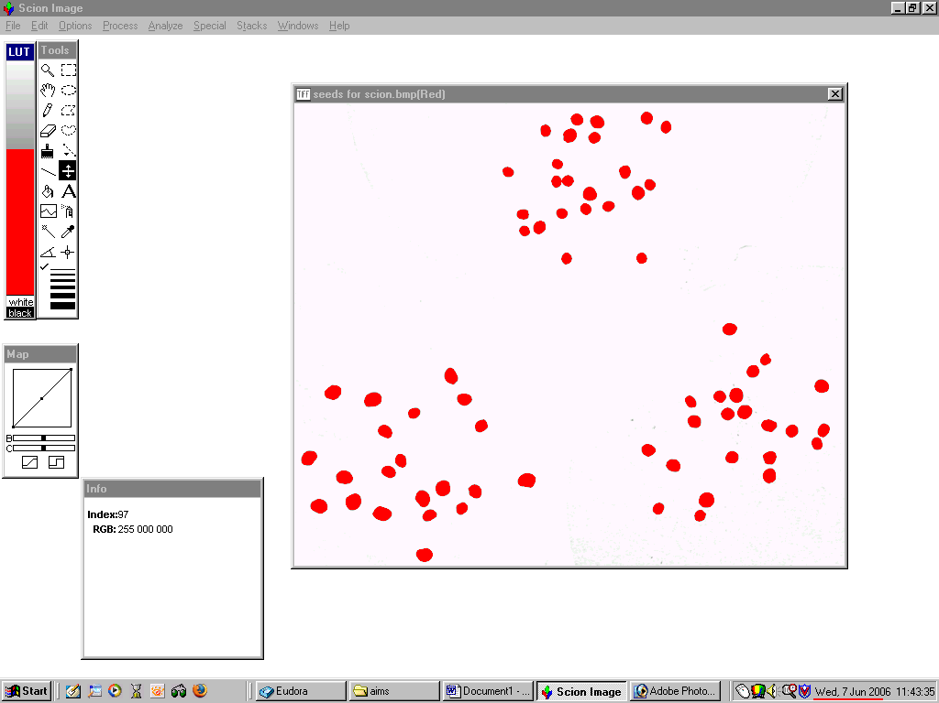

Next, select “analyze particles” from the “Analyze” pull-down menu. This window will open. You can set the minimum size of red object that will be included in the analysis as well as the maximum size of object. The only changes to the defaults are to set the minimum size to 50 and to check the “outline particles” box. The latter will cause the particles identified as falling between the size limits to be outlined in black and numbered. Press “OK”
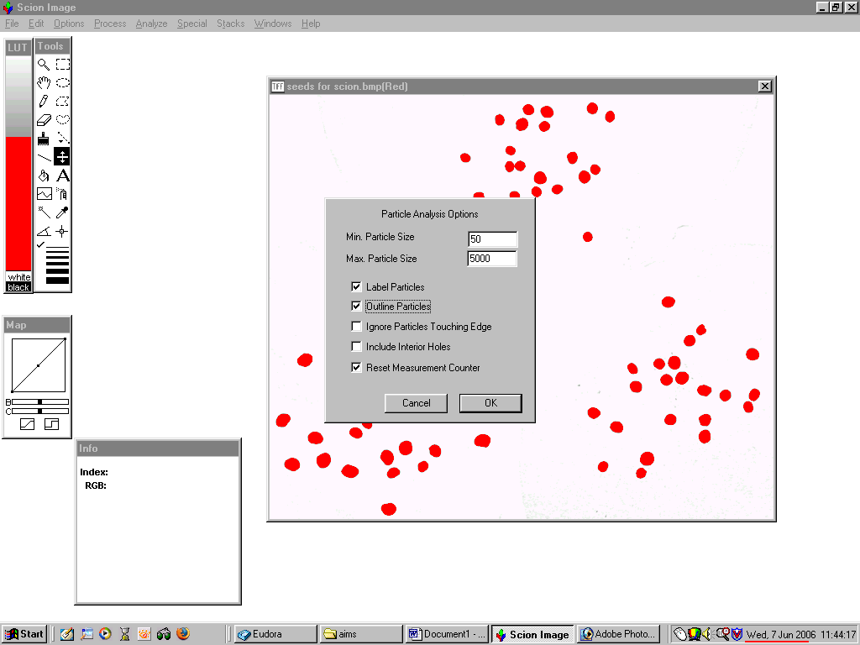

You should see a screen like this in which the particles have been outlined and numbered.
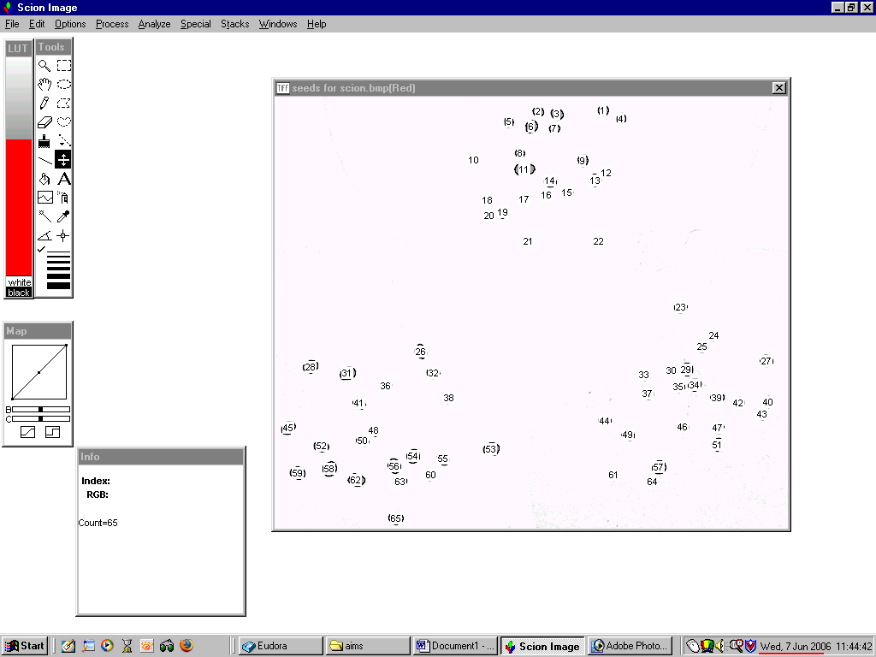

Select “show results” from the “analyze” pull-down and each numbered particle will have an area (cross-sectional) in pixels and a mean intensity. The number of particles (seeds) detected is 65:

